**INDUSTRY INTERNSHIP REPORT ON**

**BHARAT HEAVY ELECTRONICALS LTD**

**ELECTRONIC DIVISION(EDN)**

**BY**

**LAKSHMI**

**ENROLLMENT NO:- 1-43648118724**

*For partial fulfilment of the requirements of the first-year curriculum of the two years full time AICTE PGDM Program*

**Submitted to**



RAMAIAH INSTITUTE OF MANAGEMENT STUDIES

Gokula, Bangalore

**CERTIFICATE FROM THE GUIDE**

This is to certify that the organization study report  on “BHARAT HEAVY ELECTRONICALS LTD ELECTRONIC DIVISION (EDN)” by LAKSHMI, Enrolment no: 1-43648118724 carried out in partial fulfilment for the award of degree of POST GRADUATE DIPLOMA IN MANAGEMENT at Ramaiah Institute of Management Studies, Bangalore has been prepared under my guidance and direction. This study report is an original work and has not been submitted earlier to any University/Institute as per my knowledge and belief.

.

**Verified By :**

**(CO- Ordinator PhD, MBA, BE**

**Associate Professor. Dr. Prasad Linganna)**

**INTERNSHIP/ PROJECT WORK /ORGANIOSATION STUDY CO-ORDINATOR**

**THE INSTITUTE SIGNATURE AND SEAL**

TABLE OF CONTENT

|  |  |  |
| --- | --- | --- |
| CHAPTERS | TABLE OF CONTENT | PAGE |
|  | ACKNOWLEDGEMENT | 3 |
| 1 | INTRODUCTION TO BHEL | 5 |
| 2 | RESEARCH DESIGN | 23 |
| 3 | INTRODUCTION TO FINANCE | 33 |
| 4 | DATA ANALYSIS AND INTERPRETATION | 45 |
| 5 | FINANCIAL STATEMENT OF BHEL | 56 |
|  | LEARNINGS AND OUTCOMES |  |

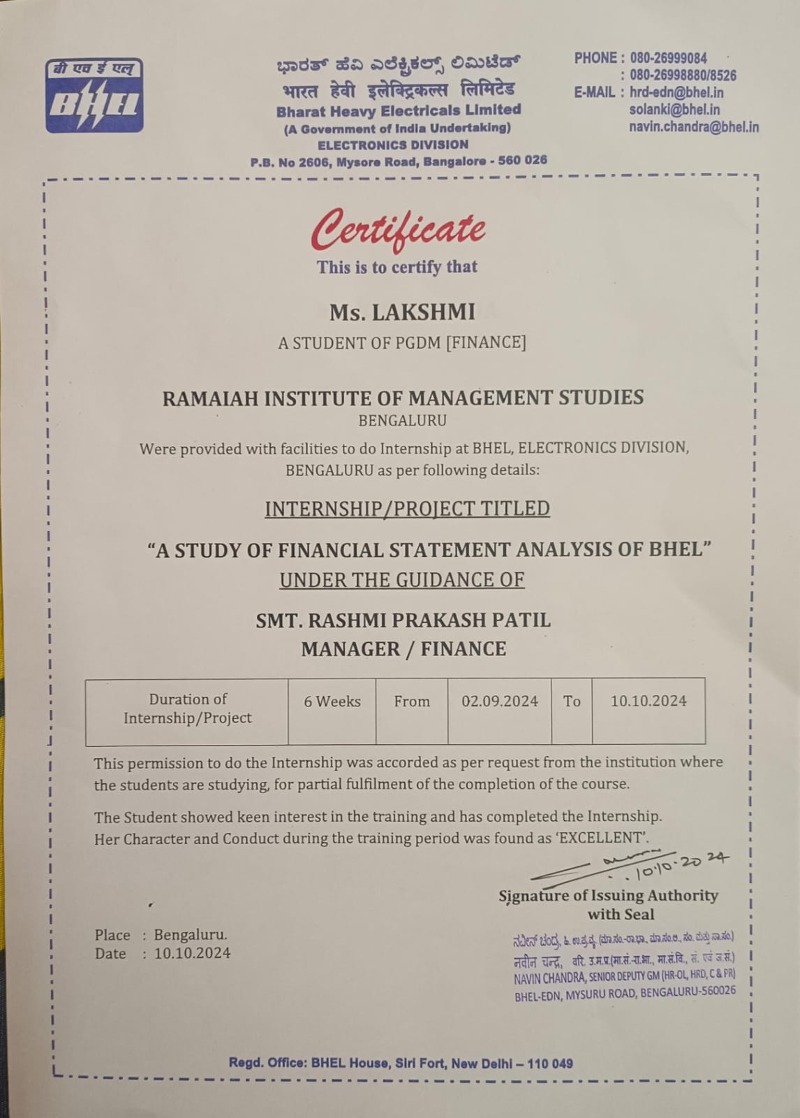**ACKNOWLEDGMENT**

I would like to thank the founder trustees Dr. M.R Pattabiram and Mrs. Anitha Pattabiram for providing the infrastructure and the facilities to complete my internship. I would also like to thank Dr.Swapna, Principal of RIMS for being a constant source of inspiration. My thanks are due to **PhD, MBA, BE**

**Associate Professor. Dr. Prasad Linganna** Sir (My internal Guide at RIMS) and **CA .Smt. Rashmi Prakash Patil** Mam (Finance Manager) (My external Guide at Company) for their guidance during the period of my Internship.

**PhD, MBA, BE**

**Associate Professor .Dr. Prasad Linganna**

RIMS, Bengaluru.

zz

CHAPTER-1

INTRODUCTION TO BHEL



BHEL is India’s largest engineering and manufacturing enterprise in the energy and infrastructure sectors. Established in 1964, we are a leading power equipment manufacturer globally and one of the earliest and leading contributors towards building an Aatmanirbhar Bharat.

We serve our customers with a comprehensive portfolio of products, systems and services to its customers in the areas of power-thermal, hydro, gas, nuclear & solar PV, transmission, transportation, defence & aerospace, oil & gas, and water. Right from developing country’s power generation capacity to creating multiple capabilities in country’s core industrial & strategic sectors, BHEL is deeply aligned to the vision of a self-reliant India.

Consistent expenditure of more than 2.5% of its revenue on R&D and innovation; establishment of world-class assets, development and absorption of new technologies; and creating sustainable business solutions and contribution to the society at large through initiatives in skilling youth, health & hygiene, education, cleanliness and environment protection, stand a testimony to our commitment. A resilient workforce, more than 32,000 strong is the driving force behind our journey over the years

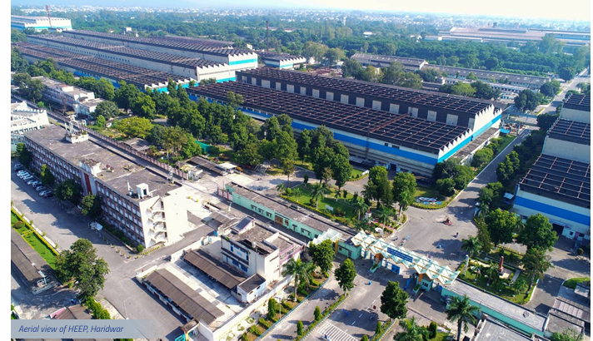

**POWER SECTOR**

Power Sector BHEL is one of the few companies in the world having the capability to manufacture the entire range of power plant equipment, with proven capabilities for executing thermal, gas, hydro and nuclear power projects. Offerings include:

• Steam turbines, generators, boilers and matching auxiliaries for fossil-fuel applications up to 1000 MW unit size

• Emission control equipment including Flue Gas Desulphurisation systems for emission control, high efficiency Electrostatic Precipitators for particulate emission control, and Boiler modification and Selective Catalytic Reduction systems for NOx emission control

• Gas turbines and generators up to 299 MW unit size • Hydro turbines and generators up to 400 MW unit size

• 220/235/540/700MWe nuclear turbine generator sets • Plant performance improvement through renovation, modernization, uprating, residual life assessment, health diagnostics and life extension of plants

**INDUSTRY SECTOR**

Industry Sector BHEL’s major offerings for Energy, Industry and Infrastructure sectors include:

• Transportation: IGBT based propulsion equipment (traction converter/auxiliary converter/Vehicle Control Unit), traction transformers for electric Locos and ACEMUs/ MEMUs, EMU coaches, electric locomotives upto 9000 HP and diesel electric locos upto 3000 HP

• Renewables: EPC solutions from concept to commissioning for grid connected and standalone solar PV applications

• Defence & Aerospace: Strategic equipment for Indian defence forces including Super Rapid Gun Mount & Integrated Platform Management System for naval ships, compact heat exchangers, space grade Lithium ion cells, space grade solar panels and space grade batteries, Hot forming of spacecraft propellant tank, Forming of Titanium Shell/Domes, welding & machining of Titanium sheet and tube

• Energy storage solutions & other business areas: EPC solutions for Electric vehicle charging station including Solar Based EV Charging stations, battery energy storage systems; EPC solutions for railway track electrification; complete water management solutions for power plants, industries and municipal applications; medical oxygen plants

• Captive Power & process plants: standalone STGs, BTG package, GTG, Refinery CPP on EPC basis, UB package, Downstream oil and Gas packages.

• Transmission: EHV substations ranging up to 765 KV, UHV substations and HVDC converter stations up to ±800KV, power transformers, shunt reactors, vacuum switchgear, gas insulated switchgears, ceramic insulators, Flexible AC Transmission system devices etc.

• Industrial products: Oil rigs, wellheads & Xmas tree valves, mechanical packages, fabricated equipment & boiler feed pumps, compressors & AC machine.

**Here are the key performance highlights for FY 2023-24:**

* Achieved highest ever order inflow of77,907 Crore,

with orders in both thermal power and diversified sector

such As transportation ,defence ,and thermal.

* Secured orders worth `55,642 Crore in the power sector, including the largest power segment order of NLCIL Talabira and the E&M package for India’s biggest hydro power plant, Dibang.
* Industry segment saw the highest ever order inflow of 21,951 Crores, including the largest order for the supply of 80 Vande Bharat Trains. Also secured prestigious orders for 20 Upgraded Super Rapid Gun Mounts (SRGM) for Indian Navy warships.
* With a renewed focus on project execution, the company posted a revenue of `22,921 Crores for 2023-24. We expect revenues to grow in the coming years, having posted a Profit After Tax of`260 Crores and EBITDA of `1,201 Crores for FY 2023-24.
* Showcased expertise in overseas project execution by commissioning the Maitree Super Thermal Power Plant in Bangladesh, inaugurated by the Prime Ministers of India and Bangladesh.
* Expanded renewable energy footprint by commissioning the 100MW Raghanesda Phase-2 solar project in Gujarat and the 8MW Tamarind Falls solar project in Mauritius.
* Dedicated North Karanpura and Telangana Thermal Power Plants to the nation and achieved significant milestones with the capacity addition for Unit 3 of the Kakarapar Atomic Power Project.
* Successfully commissioned flexible operations capabilities at Adani’s Raigarh, West Bengal Power Distribution Company’s Sagardighi, and Tata’s Trombay plants.

Energized all three substations associated with the POWERGRID Neemuch Transmission System within the stipulated timelines

* Energized all three substations associated with the POWERGRID Neemuch Transmission System within the stipulated timelines
* Manufactured India’s first set of catalysts for Selective Catalytic Reduction for limiting NOx emissions for the 5x800 MW Yadadri Thermal Power Station in Telangana.
* Achieved addition of 6 GW of electricity generation capacity in utility, industrial and international sectors.

**Strategic Initiatives and Future Outlook**

* We are committed to addressing opportunities across our business segments. Key strategic initiatives include:
* of Central Procurement Cell (CPC) for timely and cost-effective procurement of packages for projects, and Unified Procurement Cell (UPC) for procurement consolidation and cost reduction of raw material/commodities.
* Entered the coal gasification sector through a joint venture with Coal India Ltd to set up a Coal to 2,000 TPD Ammonium Nitrate Plant using BHEL’s in-house developed PFBG technology.
* Signed a Technical Assistance and License Agreement (TALA) with General Electric Technology GmbH Switzerland for addressing Gas Turbines market.
* a process for methanol production from coal, and Dimethyl Ether (DME) from methanol to reduce import dependence using Indian coal.
* Formed partnerships with global OEMs to explore opportunities in the defence sector, specifically for air defence guns and marine gas turbines.
* Actively participating in bids to secure high-voltage direct current (HVDC) business in the transmission domain.
* Entered strategic partnership agreements for new areas like railway signaling and electrolyser manufacturing.

LEADERSHIP AT BHEL

Board of Directors as on 25th July 2024

FUNCTIONAL DIRECTORS

Shri Rajesh Kumar Dwivedi

Director (Finance)

Shri K. Sadashiv Murthy

Chairman & Managing Director

Shri Krishna Kumar Thakur

Director (Human Resources)

Ms. Bani Varma

Director (Industrial Systems & Products)

Shri Tajinder Gupta

Director (Power)

Shri Jai Prakash Srivastava

Director (Engineering, R&D)

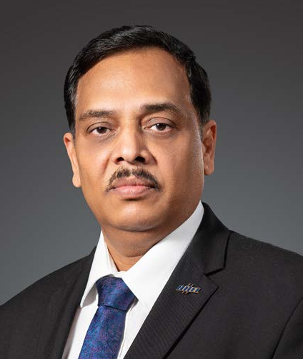

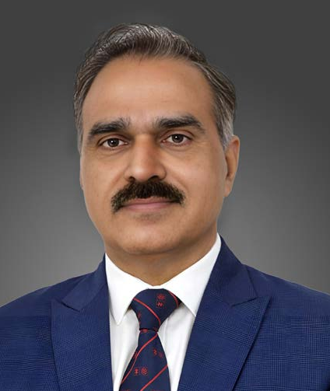

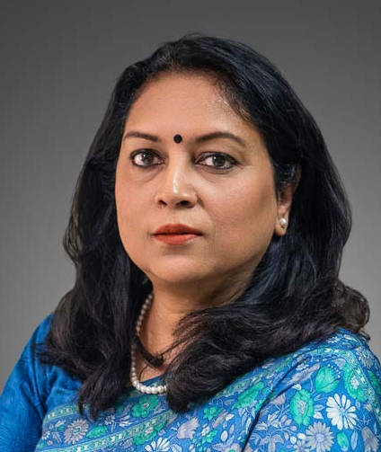

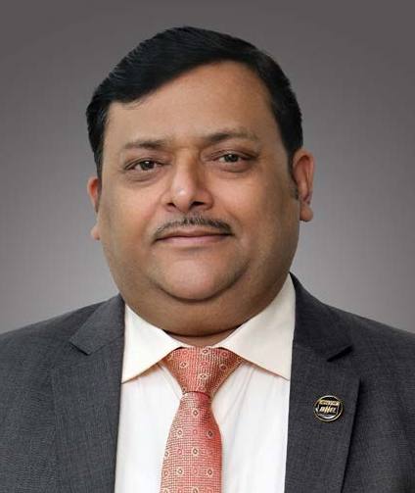

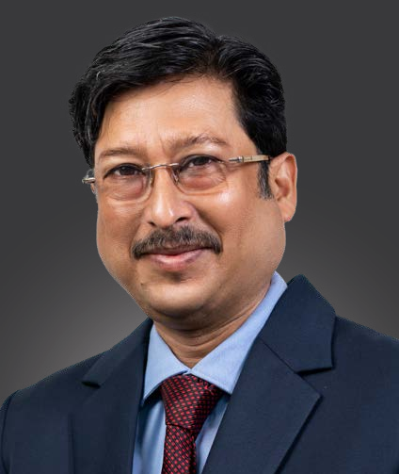

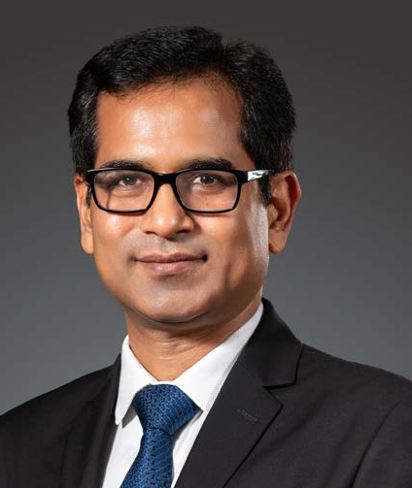

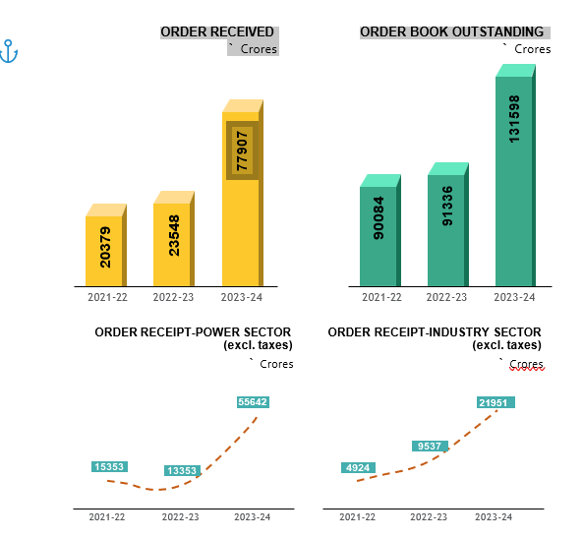

**STATE OF COMPANY'S AFFAIRS**

The year 2023-24 has been momentous in terms of order inflows which reached its zenith at I77,907 Crores, with the company receiving several prestigious orders, not only in its core thermal power business but also in diversified segments of transportation, defence etc. The company has maintained its leadership position in thermal main power plant business in the country. The Industry segment also witnessed the highest ever order inflow of I21,951 Crores. A major milestone during FY 2023-24 was achieved by securing one of the largest order for the supply of 80 numbers Vande Bharat Trains in consortium as Lead Partner. The total outstanding Order Book as on March 31, 2024 stands at I1,31,598 Crores (net of taxes), with the executable Order Book being I1,23,916 Crores.

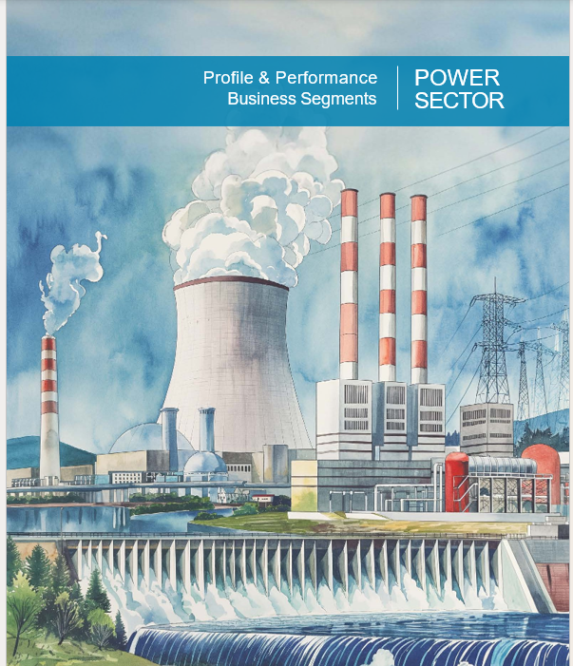

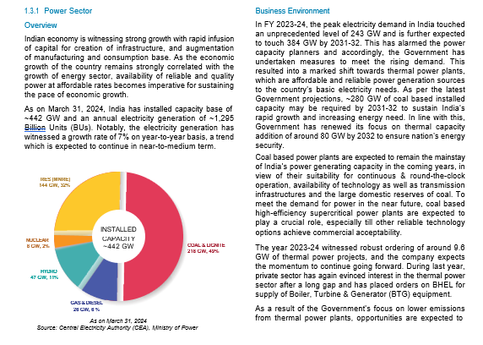

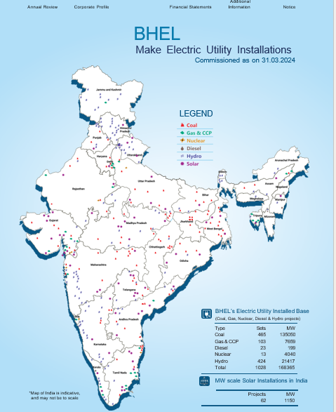

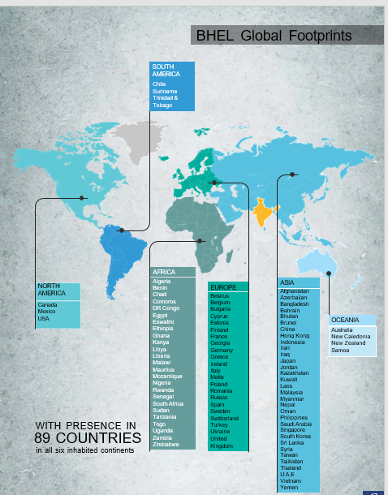

**Vision, Mission & Values**



BHEL's Mission

BHEL's Vision



**Governance**

We are stewards of our shareholders' investments and we take that responsibility very seriously. We are accountable and responsible for delivering superior results that make a difference in the lives of the people we touch.

**Respect**

We value the unique contribution of each individual. We believe in respect for human dignity and we respect the need to preserve the environment around us.

**Excellence**

We are committed to deliver and demonstrate excellence in whatever we do.

**Loyalty**

We are loyal to our customers, to our company and to each other.

**Integrity**

We work with highest ethical standards and demonstrate a behavior that is honest, decent, and fair. We are dedicated to the highest levels of personal and institutional integrity.

**Commitment**

We set high performance standards for ourselves as individuals and our teams. We honour our commitments in a timely manner.



THE VALUES that inspire BHEL

**Innovation**

We constantly support development of newer technologies, products, improved processes, better services and management practices.

**Teamwork**

We work together as a team to provide the best solutions & services to our customers. Through quality relationships with all stakeholders, we deliver value to our customers.

**BHEL An Overview**

* India's premier state-owned public sector enterprise Bharat Heavy Electricals Limited (BHEL) has been playing a pivotal role in shaping the engineering and manufacturing capability in India across several core sectors, including power generation and transmission, transportation, renewables, water, oil & gas and defense & acrospace, notching up an annual revenue of around 4 billion USD.
* BHEL, has established strong linkages with other public sector enterprises as well as research institutes in India and is also having technology tie-ups with leading OEM's in various sectors.
* With 16 manufacturing facilities spread across the country that manufacture equipment compliant with latest national and international standards, BHEL's state- of-the-art facilities specialize in engineering, manufacturing, testing, aftermarket services for equipment in the power sector segment and various industrial sectors These manufacturing units are supported by four overseas offices, four regional offices, eight service centers and 15 regional marketing centers to deliver value to ns customers
* BHEL is credited as one of India's largest employers, in the engineering sector with more than 34,000 highly skilled employees which includes 9,000 engineers with qualifications, experience and skills spanning a wide range of technology areas. Needless to say, BHEL's employees have been one of the strongest pillars in building this successful business
* With an R&D spend of over 2.5% of the annual turnover, BHEL is one the highest in the capital goods manufacturing industry in India. BHEL's dedicated R&D center in Hyderabad has been instrumental in shaping technology and innovative manufacturing capabilities
* BHEL, has established over 75 technology collaborations with several global players over the years and these partnerships have helped both parties by sharing of technologies, know-how and resources.

**Products:**

*Power

*Air Preheaters

*Boilers

*Control Relay Panels

*Electrostatic Panels

*Fabric Filters

*Fans

*Gas Turbines

*Hydro power plant

*Piping Systems

*Pulverizes

*Pumps

*Seamless Steel Tubes

*Soot Blowers

*Steam Generators

*Steam Turbines

*Turbo Generator

*Valves

*Steam Turbines

*Compressors

*Turbo Generators

*Heat Exchangers

*Pulverizes

*Switch Gears

*Gear Boxes

*Oil Rigs

**Services:**

*Power Generation Systems

*Tumkey power stations

*Combined-cycle power plants

*Cogeneration systems

*Modernization and rehabilitation of power stations

*Erection commissioning, operation and maintenance services’

*Spares management.

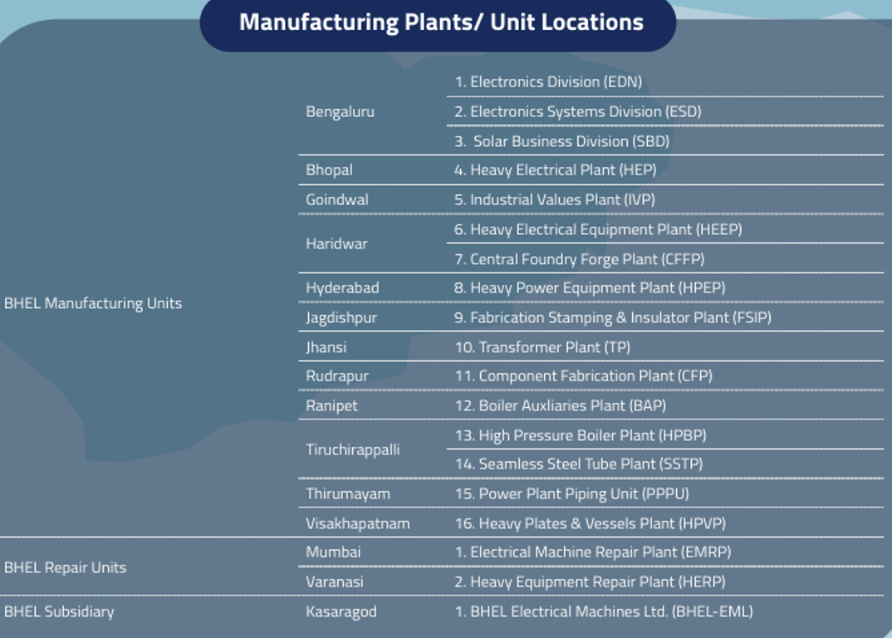

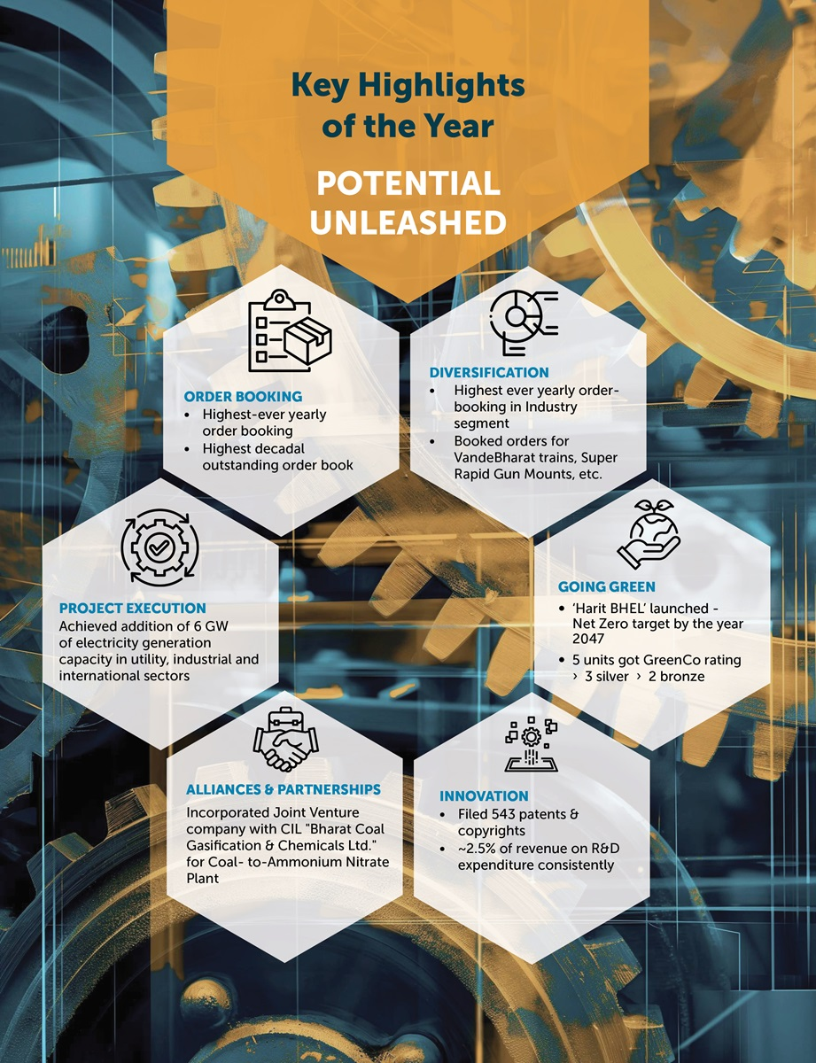

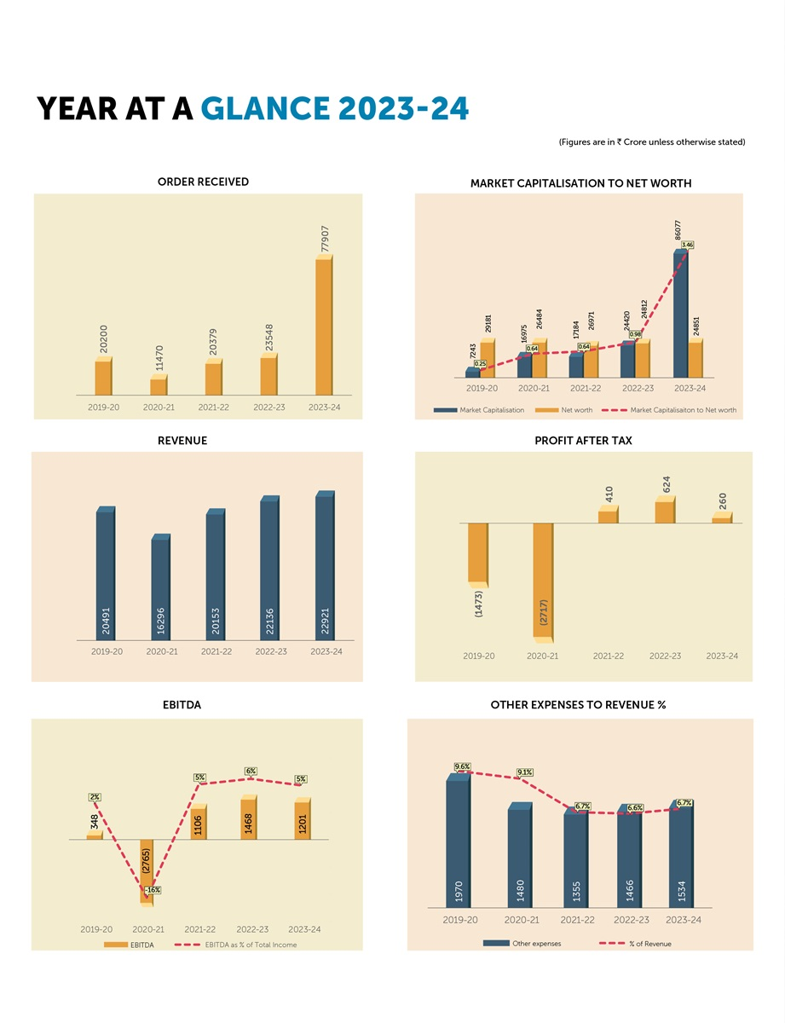

**Technology for a sustainable future:**

• In house development of Advanced Ultra Supercritical (AUSC) and Coal to Methanol technologies progressing

• Spearheading the development, installation and indigenisation of emission control equipment for coal based power plants in India

• Carbon footprint avoidance of nearly 26,118 MT MT of CO2-equivalent through in-house 28MWp solar power installations

• Developed efficient EHV Transmission systems and products (including ±800KV HVDC)

• 12 townships of BHEL units declared as Single Use Plastic

**Free Unparalleled contribution in core sectors:**

• 6,90,000+ MVA transmission equipment supplied

• 32,550+ AC machines supplied

• 760+ Locos supplied to Indian Railways and Industries

• 410+ Compressors supplied and 90 Oil drilling Rigs- Supplied

• 13000+ Well Heads & Christmas Tree valves supplied

•40+ Super Rapid Gun Mount supplied for Indian Navy ships.

**Innovation:**

• R&D Expenditure consistently >2.5% of revenue

• Collaborative R&D with leading academic institutions & research organizations

• Five research institutes; 14 Centres of Excellence

• In-house R&D Centres of 12 Manufacturing units & Divisions recognized by DSIR

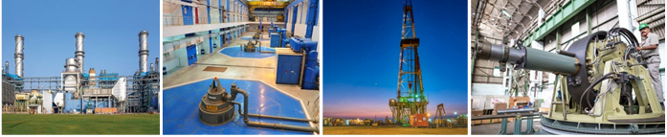

CHAPTER-2

RESEARCH DESIGN

TOPIC:

FINANCIAL STATEMENT AND ANALYSIS

MEANING,

Financial statements (or financial reports) are formal records of the financial activities of a business, person, or other entity. In British English, including United Kingdom company law, financial statements are often referred to as accounts, although the term financial statements is also used, particularly by accountants,

Financial statements provide an overview of a business or person's financial condition in both short and long term. All the relevant financial information of a business enterprise, presented in a structured manner and in a form easy to understand, are called the financial statements. There are four basic financial statements:

**1. Balance sheet:** also referred to as statement of financial position or condition, reports on a company's assets, liabilities, and net equity as of a given point in time.

**2. Income statement:** also referred to as Profit and Loss statement (or a "P&L"), reports on a company's income, expenses, and profits over a period of time. Profit & Loss account provide information on the operation of the enterprise.These include sale and the various expenses incurred during the processing state.

**3.Statement of retained earnings:** explains the changes in a company's retained earnings over the reporting period.

**4. Statement of cash flows:** reports on a company's cash flow activities, particularly its operating, investing and financing activities.

For large corporations, these statements are often complex and may include an extensive set of notes to the financial statements and management discussion and analysis. The notes typically describe each item on the balance sheet, income statement and cash flow statement in further detail. Notes to financial statements are considered an integral part of the financial statements.

**The data has been collected from various financial statements:**

* Balance Sheet
* Profit and loss account
* Annual report
* Cash flow statement

**OBJECTIVES OF BHEL**

**1. Business Mission:** To maintain the leading position as supplier of facilities for utilization and conservation of energy for applications in the areas of electric power, transportation, oil and gas exploration and industries. Utilize company's capabilities and resources to expand business into allied areas and other priority sectors of the economy like communication, electronics and technological advancements.

**2. Growth:** To ensure a steady growth by enhancing to the competitive edge of BHEL in existing business, new areas and international operations as to fulfil nations expectations from BHEL.

**3. Profitability:** To provide adequate returns on capital employed primarily through improvements in operational efficiency, capacity, utilization and productivity and generate adequate internal resources to finance the company's growth.

**4. Customer Focus:** To ensure customer satisfaction by providing them with increased value for their money through international standards of product quality, performance and superior customer service.

**5.People Orientation:** To enable each employee to achieve his potential attributes, improve his capabilities, perceive his roles and responsibilities and participate to contribute positively to the growth and success of the company.

**6. Technology:** To achieve technological excellence in operations through developing indigenous technologies and efficient absorption and adaption of important technologies to suit business needs and priorities.

**7. Image:** To fulfil the expectations of stakeholders like Government as owner, employees, customers and the country at large have from BHEL.

**BHEL FINANCE DEPARTMENT**

Finance Department

Like every manufacturing company, BHEL also has its own separate finance department which deals with the different financial matters of the company. The finance department of BHEL is sub-divided into various sections and the work flow is divided among these sections which are consolidated and put together as a whole at the end and the final accounts are prepared and then the decision making process begins and targets are set for the next financial year. The various sections into which the finance department is divided are:

**NAME OF THE SECTION:**

1.Works Section

2. Provident Fund Section

3. Miscellaneous Bills Section

4. Revenue Section

5. Cash Planning Section

6. Books & Budget Section

7. Sales Section

8. Indigenous Purchase Section

9. Foreign Purchase Section

10. Cost Section

11. Stores Section

12. Pay Section

13. Time and Wages Section

14. Assets Section

**Training:**

**Scope:**

This is essentially limited to the product quality (that is general management, behavioural management, technical and skill oriented programs).

Training for safety related aspects are given by the safely department and for quality related by the quality department

**Responsibility:**

The responsibility of identifying the training needs of all individuals lies with the concerned controlling officers/HOD and group heads.

The responsibility of consolidating and listing, in the order of priority, the program's to be conducted, in order to impart et the necessary training lies the head of HRDC

**Development:**

Development Programs

*Developmental programs are conducted for all categories of employees i.e., Executive, Supervisors and Artisans.

*The company for this purpose invites faculty from outside.

*Counselling Programs

*Counselling programs are undertaken for employees who are irregular to work,

*Uninterested in the work, etc.

*company encourages suggestions, group work etc., and hence motivate the employees.

**Performance Appraisal:**

Performance evaluation and thereby performance appraisal at BHEL is done internally by the immediate concerned officer. The employees are given points based on the performance Organization Structure of BHEL.

BHEL is spread out over various parts of the country from Haridwar in North to Tiruchi in South. Centralized policy making and decentralized administration Unit managers have complete authority and power Always has been reviewing its organizational structure to ensure customer needs are fulfilled and internal synergy is maximized BHEL is commercial organization. The Powers of company officials are well defined at all levels in the organization. The duties are assigned from time to time.

ORGANIZATION CHART OF BHEL

EXECUTIVE DIRECTOR

GENERAL MANAGER

ASSISTANCE GENERAL MANAGER

SENIOR DGM

DGM

SENIOR MANAGER

MANAGER

DEPUTY MANAGER

SENIOR OFFICER/ENGINEER

OFFICER/ENGINEER

SUPERVISIOR



CLERKS

**GLOBAL PRESENCE**

* Africa
* Asia
* Europe
* North America
* South America

**MAJOR CUSTOMER OF BHEL**

* OGICA
* GEM
* ONGC-Oil and Natural Gas Corporation
* NTPC-National Thermal Power Corporation
* Indian Railways
* NPC-Nuclear Power Corporation
* Hydro Power Projects
* The TATA power company ltd
* ISRO-Indian space Research Organization
* NTPC

**BHEL CORPORATE RESPONSIBILITY (CSR)**

BHEL, a global engineering enterprise providing solutions for a better tomorrow, is committed towards holistic welfare of the society by undertaking CSR activities within the ambit of Schedule- VII of the Companies Act, 2013, as amended from time to time. However, thrust areas for CSR activities will be:

**Inclusive India:** Mitigation of hunger and poverty through livelihood promotion/ augmenting income generation, Imparting vocational Skills,

**Healthy India:** Promoting health care including preventive health care and sports;

**Clean India:** Sanitation and making available Safe Drinking Water, Cleaning and preserving the Rivers. Clean surroundings; toilets in schools specially for girls:

**Educated India:** Promoting education with thrust on informal education to reduce dropouts at primary school level, value education, digital education.

**SWOT Analysis BHEL**

**SWOT (Strength, Weaknesses, Opportunities and Threats) analysis of BHEL**

**Strengths:**

Sound engineering base and ability to assimilate

Relatively stable industrial relationship

• Access to contemporary technologies with the support from renowned collaborators.

Ability to set up power plants on turnkey basis, complete know-how for manufacture of entire equipment is available with the company.

Ability to manufacture or procure to supply spares.

• Fully equipped to take capital maintenance and servicing of the power plants.

• Largest source of domestic business leading to major presence and influence in the market.

• Ability to successfully overhaul and renovate power stations equipment of different international companies.

Low labour cost.

• Sound financial position in terms of profitability and solvency.

Low debt equity ratio (even lower than 0.5:1) for all the years under study, enabling company to raise capital.

**Weaknesses:**

• Difficulty in keeping up the commitments on the product delivery and desired sequence of supplies.

• Larger delivery cycles in comparison with international suppliers of similar equipment.

• Inability to provide supplier's credit, soft loans and financing of power projects.

Lack of effective marketing infrastructure

Due to poor financial position of state electricity boards, which are the major customers of BHEL in India, liquidity position of BHEL is not satisfactory

Being a public sector company BHEL is suffering from sab optimality of control due to 1. Displacement of social objectives by political objectives, which may lead to redundant costs and also rising costs

2. Direct political intervention in managerial decision over an arm length relationship that would restrict government's task of setting appropriate managerial incentive structure.

3. Private goals that lead to budget growth and employment growth.

4. Internal inefficiencies in bureaucratic activity

**Opportunities:**

Demand for power and hence plant equipment is expected to grow.

• Private sector power plants to offer expanded market as utilities suffers resource crunch • Ageing power plants would give rise to more spares and services business.

Life expansion program for old power stations.

Export opportunities.

Easy processing of joint ventures/ collaboration/import/acquisition of new technology.

Financial and operational autonomy for profit making public sector enterprises. To make the public sector more efficient government has decided to grant enhanced autonomy and delegation of powers to the profit making public sector enterprises.

**Threats:**

Increased competition both national and international.Multilateral agencies reluctant to lend to power sector because of poor financial management of S.E.Bs

• More concessions to private sector and not to government owned utilities like NTPC or S.E.Bs, so future power projects would be opened up in private sector

• Level playing ground not available, foreign companies spending much more on business promotion tactics.

CHAPTER-3

INTRODUCTION TO FINANCE

Finance is a term for matters regarding the management, creation, and study of money and investments. It involves the use of credit and debt, securities, and investment to finance current projects using future income flows. Because of this temporal aspect, finance is closely linked to the [time value of money](https://www.investopedia.com/terms/t/timevalueofmoney.asp), [interest rates](https://www.investopedia.com/terms/i/interestrate.asp), and other related topics.

Finance can be broadly divided into three categories:

* Public finance
* [Corporate finance](https://www.investopedia.com/terms/c/corporatefinance.asp)
* [Personal finance](https://www.investopedia.com/terms/p/personalfinance.asp)

There are many other specific categories, such as [behavioural finance](https://www.investopedia.com/terms/b/behavioralfinance.asp), which seeks to identify the cognitive (e.g., emotional, social, and psychological) reasons behind financial decisions.

**Understanding Finance**

"Finance" is typically broken down into three broad categories: public finance, corporate finance, and personal finance. Public finance includes tax systems, government expenditures, budget procedures, [stabilization policy](https://www.investopedia.com/terms/s/stabilization-policy.asp) and instruments, debt issues, and other government concerns. Corporate finance involves managing assets, liabilities, revenues, and debts for a business. Personal finance defines all financial decisions and activities of an individual or household, including budgeting, insurance, mortgage planning, savings, and [retirement planning](https://www.investopedia.com/terms/r/retirement-planning.asp).

**Key Finance Terms**

These are some key finance terms you should be familiar with.

* **Asset**: An asset is something of value, such as cash, real estate, or property. A business may have current assets or fixed assets.
* **Liability**: A liability is a financial obligation, such as debt. Liabilities can be current or long-term.
* **Balance sheet**: A balance sheet is a document that shows a company's assets and its liabilities. Subtract the liabilities from the assets to see the firm's net worth.
* **Cash flow**: Cash flow is the movement of money into and out of a business or household.
* **Compound interest**: Unlike simple interest, which is interest added to the principal one time, compound interest is calculated and added periodically. This results in interest being charged not only on the principal, but also on the interest already accrued.
* **Equity**: Equity means ownership. Stocks are called equities, because each share represents a portion of ownership.
* **Liquidity**: Liquidity refers to how easily an asset can be converted to cash. For example, real estate is not a very liquid investment, because it can take weeks or months to sell.
* **Profit**: Profit is the money left over after expenses. A profit and loss statement shows how much a business has earned or lost for a particular period.

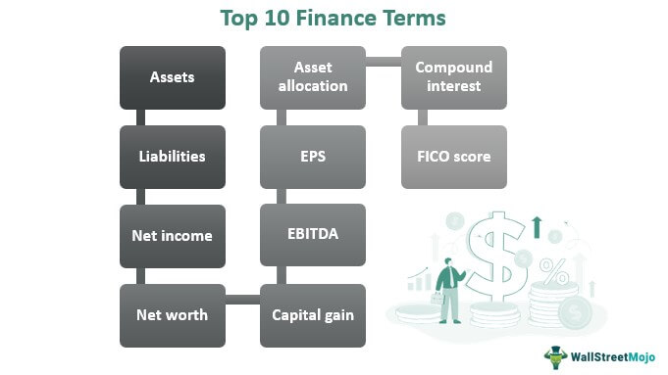

**Features of finance**

* **Time Value of Money**: One of the fundamental principles of finance is that money has a time value. A dollar today is worth more than a dollar in the future due to the potential to earn interest or returns. Finance incorporates concepts like present value, future value, and discounting to account for the time value of money.

* **Risk and Return**: Finance involves managing the trade-off between risk and return. Investments with higher potential returns typically come with higher levels of risk. Finance professionals assess risk through various metrics and strategies to optimize returns while mitigating risk.
* **Liquidity**: Liquidity refers to the ease with which an asset can be converted into cash without significantly affecting its market price. Finance involves managing liquidity to ensure that individuals, businesses, and financial markets have access to the cash they need when they need it.
* **Diversification**: Diversification is a risk management strategy that involves spreading investments across different assets, sectors, or geographical regions. By diversifying, investors can reduce the impact of adverse events on their overall portfolio.
* **Intermediation**: Finance serves as an intermediary between savers and borrowers, channelling funds from those who have excess capital to those who need it. Financial institutions such as banks, insurance companies, and investment firms play a crucial role in this process.
* **Regulation**: Finance is subject to various regulations and laws designed to ensure stability, fairness, and transparency in financial markets. Regulatory bodies oversee financial institutions, securities exchanges, and investment activities to protect investors and maintain the integrity of the financial system.

**Sources of Finance**

A company can raise capital from a variety of sources. Each source has distinct features that must be properly analysed in order to choose the greatest accessible method of obtaining finances. For all organisations, there is no one optimum source of funding. A choice of the source to be used may be made depending on the situation, purpose, cost, and associated risk.

Finance is required at the point when an entrepreneur decides to launch a business.

**Different Sources of Finance**

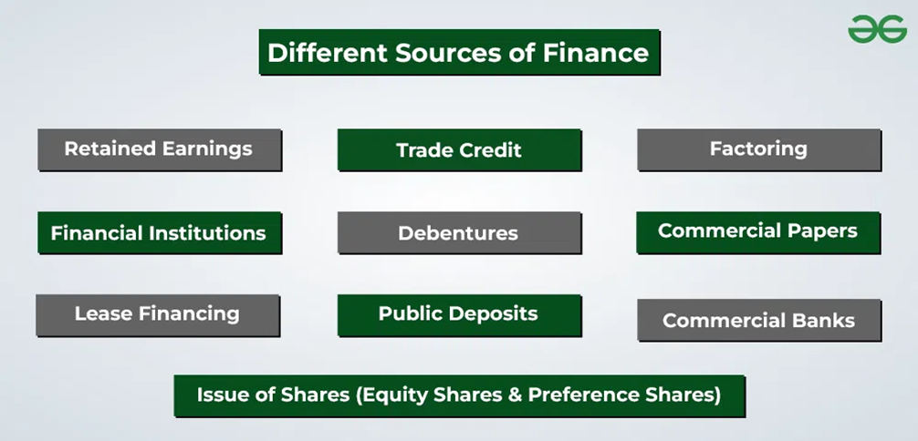

* **Retained Earnings:** The Company does not release all of its earnings or share its profits with its shareholders as dividends. A part of the net earnings may be retained in the company for future use. This is known as retained earnings. It is a source of internal finance, self-financing, or profit ploughing. The profit available for reinvestment in an organisation is dependent on a variety of factors, including net profits, dividend policy, and the age of the organisation.
* **Trade Credit:** Trade credit is credit given by one trader to another for the purchase of products and services. Trade credit facilitates the purchase of goods without the need for immediate payment. Such credit shows in the buyer of goods’ records as ‘sundry creditors’ or ‘accounts payable.’ Business organisations frequently utilise trade credit as a form of short-term finance.
* **Factoring:** Factoring is a financial service in which the ‘factor’ provides a variety of services such as:

Bill discounting (with or without recourse) and debt collection for the client:  Under this, receivables from the sale of goods or services are sold to the factor at a certain discount. The factor takes over all credit control and debt collection from the buyer and protects the company against any bad debt losses.

Factoring has basic two methods: Recourse and Non-recourse. The customer is not safeguarded against the risk of bad debts while using recourse factoring. Non-recourse factoring, on the other hand, involves the factor assuming the complete credit risk, which means that the full amount of the invoice is reimbursed to the client if the debt goes bad.

* **Lease Financing:** A lease is a contractually enforceable arrangement whereby a one party, the owner of an asset, grants the other party the right to use the asset in exchange for a monthly payment. In other terms, it is the rental of an asset for a certain amount of time. The party who owns the assets is known as the ‘lessor,’ while the party who utilises the assets is known as the ‘lessee.’ The lessee pays the lessor a predetermined periodic sum known as lease rental in exchange for the usage of the asset.
* **Public Deposits:** Public deposits are deposits gathered from the public by organisations. Interest rates on public deposits are often higher than those on bank deposits. Anyone who wants to make a monetary contribution to an organisation can do so by filling a specified form.

In return, the organisation gives a deposit receipt as proof of payment. A business’s medium and short-term financial needs can be met through public deposits. Deposits are beneficial to both the depositor and the organisation.

* **Commercial Papers:** [Commercial Paper](https://www.geeksforgeeks.org/commercial-paper-features-and-types/) (CP) is an unsecured promissory note. It was first created in India in 1990 to allow highly rated corporate borrowers to diversify their sources of short-term borrowings and to give investors an additional instrument.
* **Issue of Shares:** A share is the smallest unit of a company’s capital. The firm’s capital is split into small units and issued to the public as shares.

The capital gained via the issuance of shares is referred to as ‘[Share Capital](https://www.geeksforgeeks.org/share-capital-meaning-kinds-and-presentation-of-share-capital-in-companys-balance-sheet/).’ It’s a kind of Owner’s Fund.

* **There are two kinds of shares that can be issued:**
* [**Equity Shares**](https://www.geeksforgeeks.org/equity-shares-merits-and-demerits/)**:** These are shares that do not pay a fixed dividend, but do have ownership and voting rights. Owner of the firm refers to the company’s equity shareholders. They do not get a set dividend, but are paid dependent on the company’s profitability.
* [**Preference Shares:**](https://www.geeksforgeeks.org/preference-shares-features-types-merits-and-demerits/) Preference shares are shares that have a slight preference over equity shares. Preference Shareholders get a set dividend rate and have the right to receive their capital before equity shareholders in case of liquidation. They do not, however, have any voting rights in the company’s management.
* **Debentures:** Debentures are an effective instrument for raising long-term debt capital. A firm can raise capital by issuing debentures with a fixed rate of interest. A firm’s debenture is recognition that the company has borrowed a specified amount of money, which it commits to repay at a later period. Debenture holders are part of the company as the company’s creditors. Debenture holders get a definite stated amount of interest at predetermined periods, such as six months or a year.
* **Commercial Banks:** Commercial banks play an important role in providing finances for a variety of purposes and time periods. Banks provide loans to businesses in a variety of ways, including cash credits, overdrafts, term loans, bill discounting and the issuance of letters of credit. The interest rate imposed on such credits varies depending on the bank as well as the nature, amount, and duration of the loan.
* **Financial Institutions:** The government has established many financial institutions in the country to give financing to businesses. They provide both owned and loan capital for long- and medium-term needs. These

organisations are often known as ‘Development Banks’ since they aim to promote a country’s industrial development. In addition to financial help, these institutes conduct surveys and provide organisations with technical assistance and management services. Financial institutions provide funds for the expansion, reorganisation and modernisation of an enterprise.

**Types of Finance**

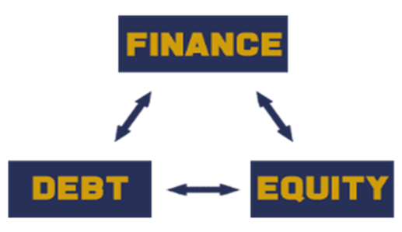

**Debt Finance:** Debt finance refers to the method of raising capital by borrowing funds from external sources, typically with the agreement to repay the borrowed amount along with interest over a specified period. In debt financing, the borrower (such as a company, government, or individual) obtains money from a lender (such as a bank, financial institution, or bond investor) and agrees to repay the principal amount borrowed plus interest according to predetermined terms.

Debt financing can be classified into three kinds-



**Equity Finance:** Equity financing is a traditional method to raise funds for a business by issuing shares. This differs from debt finance. The finance is used to seed funds for companies that are start-ups and newly established businesses. The most well-known companies use this financing to raise capital for growth.

**The various other forms of finance are –**

**Public Finance:** Public finance is the study of a state's income and expenditure. It is a study of the financial position of the state. Public finance covers the collection of funds and distribution among various aspects of state operations, considered essential duties or functions of the government.

**Personal Finance:** Personal finance is the procedure of planning and managing personal financial activities. It includes how individuals decide their budget, spend and save monetary resources over time.

**Corporate Finance:** Corporate finance encompasses financial functions essential for the smooth functioning of the business. It is a division responsible for the financial operations of an organization**.**

**Private Finance:** Private finance is a different method of financing for corporate purposes that help businesses raise funds to solve financial issues within an imposed timeframe. This approach allows companies that aren't listed on a stock exchange or do not access financing through these markets. In addition, the private plan for financial planning could be suitable for non-profit organizations.

**COMPETITORS**

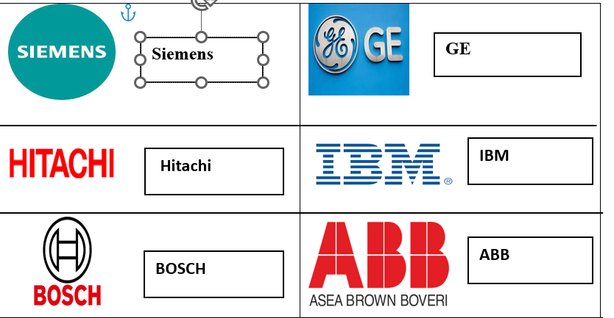

**ACHIEVEMENTS AND AWARDS**

**AWARDS**

* BHEL's innovativeness gets global recognition, Forbes ranks BHEL at No.9 in the list of the world's 100 most innovative companies.
* BHEL wins ICWAI National Awards for excellence in cost management for the sixth consecutive year, maximum number of awards conferred on BHEL among public and private sector companies.
* BHEL wins MOU excellence award for the year 2006-07 for the highest growth rate in market capitalization.
* 2010-Bhel begs EEPC'S Top export award for the 20th consecutive year.
* BHEL, gets Golden Peacock Award 2011 for Occupational Health and Safety.

**ACHIEVEMNETS**

* Certified to ISO 9001:2000
* Rajivegandhi quality award 1995
* Golden peacock-national quality award 1999
* Golden peacock-national quality award 1999-2000
* CII-EXIM Strong commitment to total quality management - 2000
* Rajivegandhi quality award 2000-01
* IMC-Bajaj national quality "Commendation Certificate" 2002
* Special commendation under Golden peacock National Quality Award 2003
* International Asia Pacific Quality Award (IAPQA) 2005

**2011**

* BHEL employees win 8 Prime Minister’s Shram Awards
* BHEL employees win 5 Vishwakarma National Awards
* BHEL unit bags 3 National Safety Awards.

**2012**

* BHEL developed India’s first ultra- high voltage AC 1200kv transformer
* BHEL wins SCOPE Meritorious award 2010-11 for best practices in Human Resource Management.
* The Hon'ble president of India, shriPranab Mukherji, president the National Energy Conservation Award 2012.

**2013**

* BHEL conferred Jury Award for lasting impact on Indian Economy.
* CMD, BHEL honored with Lakshya Business Visionary Award 2013.
* BHEL bags PSE excellence award 2013 for R&D, technology development and innovation.
* BHEL wins India Pride Award 2013 for excellence in Heavy Industries**.**

**2014**

* BHEL bags World Intellectual Property Organization (WIPO) Award for Innovative Enterprises.
* BHEL achieves milestone in the Middle East market with the commissioning of another Gas Turbine-based Power Plant in Oman.
* BHEL bags Intellectual Property Award 2014.

**2015**

* BHEL has been awarded the CBIP award for "Best Power Equipment Manufacturing Organization".
* BHEL bags "Outstanding Achievement Award" in recognition of excellence in R&D through technology in large enterprise category.

CHAPTER-4

DATA ANALYSIS AND INTERPRETATION

METHOD FOR ANALYSIS

* Comparative statement analysis
* Ratio analysis

COMPARATIVE STATENMENT ANALYSIS

**Comparative Statement Analysis** involves evaluating financial statements (such as income statements and balance sheets) over multiple periods to identify trends, patterns, and changes in a company's financial performance. By comparing current figures with past data, businesses and investors can assess growth, profitability, liquidity, and financial health. This analysis highlights percentage changes in key items like revenue, expenses, assets, and liabilities, helping stakeholders make informed decisions about the company's performance and future direction. It is commonly used in financial planning, budgeting, and investment analysis.

RATIO ANALYSIS

**Ratio Analysis** is a financial tool used to evaluate the performance and financial health of a business by analysing relationships between various financial statement items. It simplifies complex financial data and helps stakeholders make decisions.

**Types of ratio used**

* Current ratio
* Quick ratio
* Cash ratio
* Gross profit ratio
* Net profit ratio
* Return on asset ratio

**1 LIQUIDITY RATIO**

Liquidity Ratios assess a company's ability to meet its short-term financial obligations using its current assets. They help determine how quickly assets can be converted into cash to cover liabilities, ensuring the company has sufficient liquidity.

1. **CURRENT RATIO**

Current ratio = Current asset

current liabilities

**TABLE NO,1:** TABLE SHOWING CURRENT RATIO

(IN CRORES)………

|  |  |  |  |
| --- | --- | --- | --- |
| YEAR | CURRENT ASSET | CURRENT LIABILITY | RATIOS |
| 2018-2019 | 38339.89 | 23045.77 | 1.67 |
| 2019-2020 | 32703.53 | 22647.41 | 1.45 |
| 2020-2021 | 28334.02 | 20321.66 | 1.39 |
| 2021-2022 | 27861.98 | 21371.15 | 1.30 |
| 2022-2023 | 30082.28 | 23351.44 | 1.29 |
| 2023-2024 | 34545.69 | 25332.80 | 1.36 |

Analysis:

The current ratio has been gradually decreasing over the year, which might indicate that the company is becoming less able to meet its short-term obligations with the its current asset. But in the year 2023-2024 it has been increased and also the current ratio is still above 1 in all the years , which generally indicates a positive sign it’s important to note the declining trend

A current ratio above 1 suggest that the company has enough current asset to cover its short term liabilities, but higher values (closer to 2 or more ) are generally considered better as they provide a larger buffer for unexpected financial challenges.

The company should monitor its current ratio closely to ensure it remains at a healthy level a sharp decline or a current ratio consistently below I could indicate financial difficulties in meeting short-term obligations. But compared to PY that ratio has been increased

**B QUICK RATIO**

Quick ratio = (current asset – inventory)

Current liabilities

TABLE NO.2: TABLE SHOWING QUICK RATIO

|  |  |  |  |  |
| --- | --- | --- | --- | --- |
| YEAR | CURRENT ASSET | INVENTORIES | CURRENT LIABILITY | RATIO |
| 2018-2019 | 38339.89 | 8113.49 | 23055.77 | 1.31 |
| 2019-2020 | 32703.53 | 8905.46 | 22647.41 | 1.05 |
| 2020-2021 | 28334.02 | 7191.23 | 20321.66 | 1.04 |
| 2021-2022 | 27861.98 | 6560.21 | 21371.15 | 1.00 |
| 2022-2023 | 30082.28 | 6755.90 | 23351.44 | 1.00 |
| 2023-2024 | 34545.69 | 7220.57 | 25332.80 | 1.07 |

(IN CRORES)…………..

ANALYSIS:

The quick ratio has been fluctuating over the years but generally remains above 1 indicates that the company has enough quick asset to cover its current liabilities. Compared to the current ratio analysis in the previous response, the quick ratio has been increased . The quick ratio analysis as a whole shows a upward tendency over time ,which could suggest a potential liquidity issue .

(IN CRORES)……….

C .**CASH RATIO:**

Cash ratio = Cash &cash equivalents

Current liabilities

**TABLE NO.3: TABLE SHOWING CASH RATIO**

(IN CRORES)…………

|  |  |  |  |
| --- | --- | --- | --- |
| YEAR | CASH&CASH EQUIVALENTS | CURRENT LIABILITIES | RATIOS |
| 2018-2019 | 7505.34 | 23055.77 | 0.33 |
| 2019-2020 | 6418.56 | 22647.41 | 0.28 |
| 2020-2021 | 6701.43 | 20321.66 | 0.33 |
| 2021-2022 | 7153.69 | 21371.15 | 0.33 |
| 2022-2023 | 6624.58 | 23351.44 | 0.28 |
| 2023-2024 | 6157.47 | 25332.80 | 0.24 |

Analysis:

A cash ratio below indicates that the company may rely on there liquid assets to meet its short -term obligations.

The cash ratio for 2018-2019 is approximately 0.33, which means that the company had only about 33% of the cash needed to cover its current liabilities. The cash ratio decreased

Around 0.28 in 2019-2020, indicating a decline in the company’s ability to cover its current liabilities with cash & cash Equivalents.

The financial position of the company in relation to its current liabilities kept deteriorating in 2019-2020, with the cash ratio dropping further to around 0.28. This means that using exclusively cash and cash equivalents to pay short-term obligations would be difficult.

The cash ratio remained around 0.33 in 2020-2021.Athough the cash position improved slightly, the cash ratio is still below 1, indicating that the company does not have enough cash to cover its current liabilities independently.

The cash ratio dropped to 0.24 in 2023-2024 indicates that using exclusively cash and cash equivalents to pay short-term obligations would be difficult.

2 PROFITABILITY RATIO

**Profitability Ratios** are financial metrics used to assess a company's ability to generate profit relative to its revenue, assets, equity, or other financial elements. These ratios are key indicators of financial health, helping investors and management understand how well a company is performing in terms of making money.

**A. GROSS PROFIT RATIO**

**Gross Profit Ratio = Gross profit x100**

**Net sales**

TABLE NO.4 : TABLE SHOWING GROSS PROFIT RATIO

(IN CRORES)…………..

|  |  |  |  |
| --- | --- | --- | --- |
| YEAR | GROSS PROFIT | NET SALES | RATIO |
| 2018-2019 | 2057.86 | 30348.95 | 6.78 |
| 2019-2020 | -662.11 | 21486.95 | -3.08 |
| 2020-2021 | -3611.60 | 17308.44 | -20.87 |
| 2021-2022 | 436.95 | 21211.09 | 2.06 |
| 2022-2023 | 449.50 | 23364.94 | 1.92 |
| 2023-2024 | 220.33 | 23892.78 | 0.92 |

**ANALISIS:**

IN 2018-2019 , the company had positive gross profit ratio of approximately 6.78 respectively. This indicates that the company was earning a gross profit on its net sales during the year.

However , in 2019-2020 and 2020-2021, the company experienced negative gross profit ratio of -3.08 and -20.87 respectively. This suggests that the company’s cost of goods sold exceeded its gross profit ,resulting in losses at the gross profit level.

In 2022-2023 and 2023-2024 the company’s gross profit ratio improved to approximately 2.60 & 1.92, indicating that it was able to generate a small gross profit on its net sales during those years.

In 2023-2024, the gross profit ratio of the company was approximately 0.92, indicating during that the company was able to generate a small gross profit on its net sales during that year.

B )NET PROFIT RATIO:

Net profit ratio: = Net profit x 100

Net sales

TABLE NO.5: TABLE SHOWING NET PROFIT RATIO

(IN CRORES)………..

|  |  |  |  |
| --- | --- | --- | --- |
| YEAR | NET PROFIT | NET SALES | RATIO |
| 2018-2019 | 1215.39 | 30348.95 | 4.00 |
| 2019-2020 | -1472.97 | 21486.95 | -6.86 |
| 2020-2021 | -2717.14 | 17308.44 | -15.70 |
| 2021-2022 | 410.24 | 21211.09 | 1.93 |
| 2022-2023 | 447.55 | 23364.94 | 1.91 |
| 2023-2024 | 259.89 | 23892.78 | 1.08 |

In 2018-2019 the company had a positive net profit ratio of approximately 4.00 respectively. This indicates that the company was able to generate a net profit on its net sales during the year.

However ,in 2019-2020 and 2020-2021 ,the company experienced negative net profit ratio of -6.86 and -15.70 respectively. This suggest that the company incurred losses after considering all expenses, including operating expenses.

IN 2021 – 2022 the company’s net profit ratio improved to approximately 1.93,indicating that it was able to generate a small net profit on its net sales during that year.

**C RETURN ON ASSETS(ROA)**

**Return On Assets = Net income x 100**

**Total asset**

**TABLE NO.6: TABLE SHOWING RETURN ON ASSESTS RATIO**

|  |  |  |  |
| --- | --- | --- | --- |
| YEAR | NET INCOME | TOTAL ASSETS | RATIO |
| 2018-2019 | 31026.59 | 64416.01 | 0.48 |
| 2019-2020 | 22066.64 | 61271.42 | 0.36 |
| 2020-2021 | 17678.28 | 55701.24 | 0.32 |
| 2021-2022 | 21578.90 | 56708.32 | 0.38 |
| 2022-2023 | 23879.75 | 59803.91 | 0.39 |
| 2023-2024 | 24480.70 | 59417.43 | 0.41 |

Analysis :

Return on assets (ROA) Is a financial metric that measures a company’s profitability relative to its total assets.

The company had Return on assets of approximately 48% in 2018-2019. An ROA of 48% indicates that the company’s assets were efficiently used to generate profits during this year

.The ROA decreased slightly to around 36%in 2019-2020. This indicates that the company’s profitability relative to its total assets declined during this period.

In 2020-2021 ,the ROA the return on asset fell even more ,to about 32%. This suggest that throughout this year, the company’s capacity to turn a profit from its assets declined.

The Return on Assets improved to 38% in 20321-2022. While it shows a positive turn compared to the previous year, the ROA is still lower than the initial year of the analysis.

The analysis of ROA shows fluctuation over the years. The company had higher ROA In the initial year ( 2018-2019 ) but faced a decline in the year following years (2019-2020,

2020-2021 and 2021-2022)

(In 2023-2024 the ROA increased by 41% )

CHAPTER-5

FINANCIAL STATEMENT OF BHEL

* + - **Standalone Statement of Balance Sheet**
    - **Standalone statement of Profit & Loss**
    - **Standalone Statement of Cash Flows**

Standalone Balance Sheet as at March 31, 2024 (In Crore)

|  |  |  |  |  |  |  |  |  |
| --- | --- | --- | --- | --- | --- | --- | --- | --- |
| Particulars | Note | Page | As at March 31, 2024 | | As at March 31, 2023 (Restated)* | | As at April 1st, 2022 (Restated)* | |
| A. ASSETS   1. Non-current assets    1. Property, plant and equipment    2. Capital work-in-progress    3. Intangible assets    4. Intangible assets under development    5. Financial assets       1. Investments       2. Trade receivables       3. Other financial assets    6. Deferred tax assets (net of liabilities)    7. Other non-current assets | 3a 3b 4a 4b  5  6  7  8  9 | 182  182  189  189  191  192  194  195  196 |  | 2510.69 |  | 2408.74 |  | 2336.34 |
|  | 282.32 |  | 344.59 |  | 422.32 |
|  | 63.35 |  | 67.24 |  | 62.12 |
|  | 26.04 |  | 9.26 |  | 8.66 |
| 667.60 |  | 669.54 |  | 669.71 |  |
| 3224.69 |  | 3415.54 |  | 3203.84 |  |
| 206.10 | 4098.39 | 142.69 | 4227.77 | 86.73 | 3960.28 |
|  | 4201.26 |  | 4246.54 |  | 4413.44 |
| 13689.69 | 16955.50 |  | 15833.50 |
| Total non-current assets | | | 24871.74 | |  | 28259.64 |  | 27036.66 |
| 1. Current assets    1. Inventories    2. Financial assets       1. Trade receivables       2. Cash and cash equivalents       3. Bank balances other than cash and cash equivalents       4. Other financial assets    3. Current tax assets (net)    4. Other current assets | 10  6  11  12  7  13  9 | 197  192  198  198  194  198  196 |  | 7220.57 |  | 6755.90 |  | 6560.21 |
| 4785.38 |  | 3128.35 |  | 3024.75 |  |
| 1835.04 |  | 1561.34 |  | 732.62 |  |
| 4322.43 |  | 5136.73 |  | 6421.07 |  |
| 239.82 | 11182.67 | 186.44 | 10012.86 | 211.56 | 10390.00 |
|  | 229.07 |  | 226.38 |  | 119.24 |
| 15913.38 | 12099.36 |  | 9975.71 |
| Total current assets | | | 34545.69 | |  | 29094.50 |  | 27045.16 |
| TOTAL ASSETS | | | 59417.43 | |  | 57354.14 |  | 54081.82 |
| B. EQUITY AND LIABILITIES |  |  |  | |  |  |  |  |
| 3. Equity |  |  |  | |  |  |  |  |
| (a) Equity share capital | 14 | 199 | 696.41 | |  | 696.41 |  | 696.41 |
| (b) Other equity | 15 | 199 | 24154.18 | |  | 24115.98 |  | 23648.25 |
| Total Equity | | | 24850.59 | |  | 24812.39 |  | 24344.66 |
| 1. Liabilities    1. Non-current liabilities       1. Financial liabilities          1. Lease Liabilities          2. Trade payables             1. Total outstanding dues of micro enterprises and small enterprises             2. Total outstanding dues of creditors other than micro enterprises and small enterprises             3. Other financial liabilities 2. Provisions 3. Other non-current liabilities | 16  17  18  19  20 | 200  200  202  202  202 | 23.55 |  | 33.75 |  | 35.12 |  |
| - |  | - |  | - |  |
| 2292.76 |  | 2065.92 |  | 2004.48 |  |
| 325.88 | 2642.19 | 255.70 | 2355.37 | 215.10 | 2254.70 |
|  | 2489.08 |  | 4101.02 |  | 3771.21 |
| 4102.77 | 2605.81 |  | 2212.65 |
| Total non-current liabilities | | | 9234.04 | |  | 9062.20 |  | 8238.56 |

|  |  |  |  |  |  |  |  |  |
| --- | --- | --- | --- | --- | --- | --- | --- | --- |
| Particulars | Note | Page | As at March 31, 2024 | | As at March 31, 2023 (Restated)* | | As at April 1st, 2022 (Restated)* | |
| 4.2. Current liabilities   1. Financial liabilities    1. Borrowings   (ia) Lease Liabilities   * 1. Trade payables      1. Total outstanding dues of micro enterprises and small enterprises      2. Total outstanding dues of creditors other than micro enterprises and small enterprises      3. Other financial liabilities  1. Provisions 2. Other current liabilities | 21  16  17  18  19  20 | 203  200  200  202  202  202 | 8808.00 |  | 5385.00 |  | 4745.00 |  |
| 24.91 |  | 34.76 |  | 49.81 |  |
| 1157.45 |  | 1211.53 |  | 745.82 |  |
| 7538.79 |  | 8684.30 |  | 7003.77 |  |
| 1418.44 | 18947.59 | 1405.04 | 16720.63 | 1251.54 | 13795.94 |
|  | 2318.27 |  | 2796.63 |  | 3066.70 |
| 4066.94 | 3962.29 |  | 4635.96 |
| Total current liabilities | | | 25332.80 | |  | 23479.55 |  | 21498.60 |
| Total liabilities | | | 34566.84 | |  | 32541.75 |  | 29737.16 |
| TOTAL EQUITY AND LIABILITIES | | | 59417.43 | |  | 57354.14 |  | 54081.82 |

Standalone Statement of Profit and Loss

For the year ended March 31, 2024

|  |  |  |  |  |  |  |
| --- | --- | --- | --- | --- | --- | --- |
| Particulars | Note | Page | For the year ended March 31, 2024 | | For the year ended As at March 31, 2023 (Restated) | |
| INCOME |  |  |  | |  | |
| Revenue from operations | 22 | 204 | 23892.78 | | 23364.94 | |
| Other income | 23 | 204 | 587.92 | | 514.81 | |
| TOTAL INCOME | | | 24480.70 | | 23879.75 | |
| EXPENSES |  |  |  | |  | |
| Cost of raw materials consumed |  |  | 6116.27 | | 5875.28 | |
| Purchases of Bought out items |  |  | 5868.46 | | 4657.33 | |
| Civil, erection and engineering expenses |  |  | 4908.84 | | 5421.08 | |
| Consumption of stores & spares |  |  | 350.28 | | 404.18 | |
| “Changes in inventories of finished goods, | 24 | 205 | (436.74) | | (57.15) | |
| work in progress and Scrap” |  |  |  | |  | |
| Employee benefits expense | 25 | 205 | 5628.84 | | 5700.63 | |
| Other Expenses | 26 | 206 | 844.23 | | 410.86 | |
| Finance costs | 27 | 209 | 731.29 | | 521.43 | |
|  | 3.1 | 184 |  | |  | |
| Depreciation & amortisation expense | 4.1 | 189 | 248.90 | | 260.34 | |
| TOTAL EXPENSES | | | 24260.37 | | 23193.98 | |
| PROFIT BEFORE TAX | | | 220.33 | | 685.77 | |
| Tax expenses | 28 | 209 |  | |  | |
| a) Current tax | | | (112.56) |  | (111.22) |  |
| b) Deferred tax | | | 73.00 | (39.56) | 172.71 | 61.49 |
|  | | |  |  |  |  |
| PROFIT FOR THE YEAR (A) | | | 259.89 | | 624.28 | |

(In crores)

Standalone Statement of Profit and Loss

For the year ended March 31, 2024

|  |  |  |  |  |
| --- | --- | --- | --- | --- |
| Particulars | Note | Page | For the year ended March 31, 2024 | For the year ended As at March 31, 2023 (Restated) |
| OTHER COMPREHENSIVE INCOME  Items that will not be reclassified to profit or loss (net of tax)  -Remeasurement of defined employee benefits | 29 | 209 | (82.41) | (17.27) |
| OTHER COMPREHENSIVE INCOME FOR THE YEAR (B) | | | (82.41) | (17.27) |
| TOTAL COMPREHENSIVE INCOME FOR THE YEAR (A+B) | | | 177.48 | 607.01 |
| Earnings per equity share | 30 | 210 |  |  |
| (1) Basic [Face value of I2 each] |  |  | 0.75 | 1.79 |
| (2) Diluted [Face value of I2 each] |  |  | 0.75 | 1.79 |

Standalone Statement of Cash Flows

For the year ended March 31, 2024

|  |  |  |
| --- | --- | --- |
| Particulars | For the year ended March 31, 2024 | For the year ended March 31, 2023 |
| A. CASH FLOW FROM OPERATING ACTIVITIES |  |  |
| Profit /(Loss) before tax | 220.33 | 685.77 |
| Adjustments for: |  |  |
| Provision and write off | (1188.18) | (630.96) |
| Depreciation and amortisation | 248.90 | 260.34 |
| Finance cost (including unwinding of interest) | 731.29 | 521.43 |
| Interest & dividend income | (535.43) | (447.30) |
| Unrealised Foreign Exchange loss/(gain) | 56.03 | (401.85) |
| Amortisation of Government Grant | (15.62) | (8.90) |
| Others include profit on sale of investment & PPE and Impairment of Investment | (7.78) | (33.02) |
| Cash generated / (used) in operations before working capital changes | (490.46) | (54.49) |
| Adjustment for changes in working capital: |  |  |
| Trade Receivables | (2469.24) | 92.04 |
| Contract Assets | (13.70) | (2370.65) |
| Inventories | (503.04) | (192.40) |
| Loans, advances & other assets | (740.80) | (206.79) |
| Sub total | (3726.78) | (2677.80) |
| Trade payable | (962.56) | 1975.57 |
| Advances from customers, deposits and others | 1244.73 | (94.40) |
| Sub total | 282.17 | 1881.17 |
| Net cash (used in) / from working capital | (3444.61) | (796.63) |
| Cash generated / (used) in operations | (3935.07) | (851.12) |
| Income Tax paid | (158.48) | (155.54) |
| Refund of income taxes | 380.65 | 265.96 |
| Net cash (used in) / from operating activities | (3712.90) | (740.70) |
| B. CASH FLOW FROM INVESTING ACTIVITIES |  |  |
| Redemption / maturity of bank deposits (having original maturity of more than 3 months) | 1112.69 | 1358.78 |
| Interest received | 399.30 | 250.72 |
| Sale proceeds from Investment | 0.80 | 25.42 |
| Dividend received from joint ventures | 41.65 | 26.18 |
| Sale of property, plant and equipment & Intangible Assets | 8.92 | 7.76 |
| Purchase of property, plant and equipment & Intangible Assets | (232.50) | (188.40) |
| Net cash (used in) / from investing activities | 1330.86 | 1480.46 |

(In Crore)

(In crores)

|  |  |  |  |  |  |  |  |
| --- | --- | --- | --- | --- | --- | --- | --- |
| Particulars | Note | Page | For the year ended March 31, 2024 | | For the year ended As at March 31, 2023 (Restated) | | |
| OTHER COMPREHENSIVE INCOME  Items that will not be reclassified to profit or loss (net of tax)  -Remeasurement of defined employee benefits | 29 | 209 | (82.41) | | (17.27) | |
| OTHER COMPREHENSIVE INCOME FOR THE YEAR (B) | | | (82.41) | | (17.27) | | |
| TOTAL COMPREHENSIVE INCOME FOR THE YEAR (A+B) | | | 177.48 | | 607.01 | | |
| Earnings per equity share | 30 | 210 |  | |  | | |
| (1) Basic [Face value of I2 each] |  |  | 0.75 | | 1.79 | | |
| (2) Diluted [Face value of I2 each] |  |  | 0.75 | | 1.79 | | |
| Particulars | | | | For the year ended March 31, 2024 | | For the year ended March 31, 2023 | | |
| C. CASH FLOW FROM FINANCING ACTIVITIES | | | |  | |  | | |
| Proceeds from short term borrowings | | | | 3423.00 | | 640.00 | | |
| Proceeds / (repayment) of lease obligation (Principal) | | | | (34.32) | | (49.77) | | |
| Proceeds / (repayment) of lease obligation (Interest) | | | | (4.73) | | (7.27) | | |
| Dividend paid | | | | (139.45) | | (139.18) | | |
| Interest paid | | | | (588.76) | | (354.82) | | |
| Net cash (used in) / from financing activities (refer point 4) | | | | 2655.74 | | 88.96 | | |
| D. Net increase/(decrease) in cash and cash equivalents | | | | 273.70 | | 828.72 | | |
| Opening balance of cash and cash equivalents | | | | 1561.34 | | 732.62 | | |
| Closing balance of cash and cash equivalents [Refer Note 11] | | | | 1835.04 | | 1561.34 | | |

**References:**

* [**https://www.bhel.com/sites/default/files/BHEL%20Integrated%20Annual%20report%202023-24_4%20%281%29.pdf**](https://www.bhel.com/sites/default/files/BHEL%20Integrated%20Annual%20report%202023-24_4%20%281%29.pdf)
* **Previously papers and reports.**